Disatex “la armonia del color “ we are an importer and marketer of supplies for clothing. We handle several lines of work such as buttons, textiles (command example document of the products needed), closures, and supplies of dressmaking.
We are looking for new suppliers and we are interested in looking for new countries with which we can find commercial links

Encaje – lace
HSCODE 5810100000

Components: polyester

GUPIUR – guipiure
HSCODE 5810100000

it is the most important product for us
COMPONENT : POLYESTER OR POLYAMIDE

Letin – tc lace
HSCODE 5810100000
Components : polyester
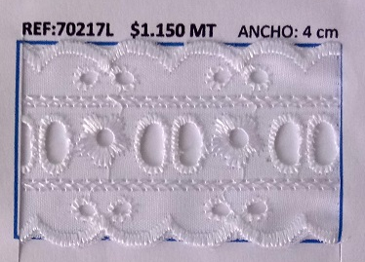

Bolillo - bobbin lace
HSCODE 5810100000
Components: cotton
