MIBS 2026 Press Conference – 29 September 2026

KUALA LUMPUR, 29 September 2026 - The 21st Malaysia International Branding Showcase (MIBS 2026) will be held from 3–5 December 2026, from 10:00 a.m. to 6:00 p.m., at Halls 2, 3, 4 and 5 of the Kuala Lumpur Convention Centre (KLCC).
MIBS 2026 is jointly organised by the Malaysia Promas International Business Society (PROMAS) and the Dewan Perniagaan Usahawan Malaysia (DPUM), with the support of the Malaysia External Trade Development Corporation (MATRADE) and the Department of Islamic Development Malaysia (JAKIM), as well as 60 local and international trade associations and business organisations. The exhibition is fully managed and coordinated by ES International Event Management Sdn Bhd, bringing together brands, manufacturers, buyers, distributors and industry professionals from Malaysia and international markets.
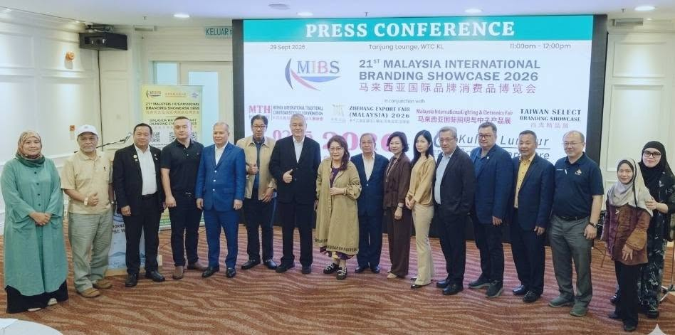
With more than 20 years of development, MIBS has established itself as an international business platform connecting brands and enterprises, facilitating market expansion and creating trade and business opportunities. MIBS 2026 will continue to help participating companies enhance brand visibility, showcase quality products, expand distribution networks and connect with potential buyers and business partners.

MIBS 2026 will feature more than 700 exhibition booths, with participating companies and delegations from Malaysia, Japan, South Korea, India, Zhejiang, Jilin and Bozhou in China, Taiwan, Indonesia, Singapore, Bangladesh, and other countries and regions. The three-day exhibition is expected to attract approximately 10,000 trade and business visitors.
The exhibition will cover a wide range of consumer and trade sectors, including health and wellness and beauty care, food and beverage and tea culture, consumer electronics and smart products, fashion apparel, fabrics and leather goods, gifts and consumer products, and home décor products. A series of specialised forums and business matching sessions will also be held in conjunction with the exhibition, including the Malaysia International Traditional & Complementary Health Forum (MTH 2026), Malaysia Tea Culture Forum 2026, Malaysia International Lighting & Electronics Business Matching 2026, Zhejiang Export Products (Malaysia) Business Matching 2026, and Jilin Export Products & Taiwan Select Business Matching 2026, further enhancing the exhibition as a diversified platform for product showcasing, international sourcing, business matching and cross-border collaboration.
Exhibition Highlights: Business Matching & Industry Exchange
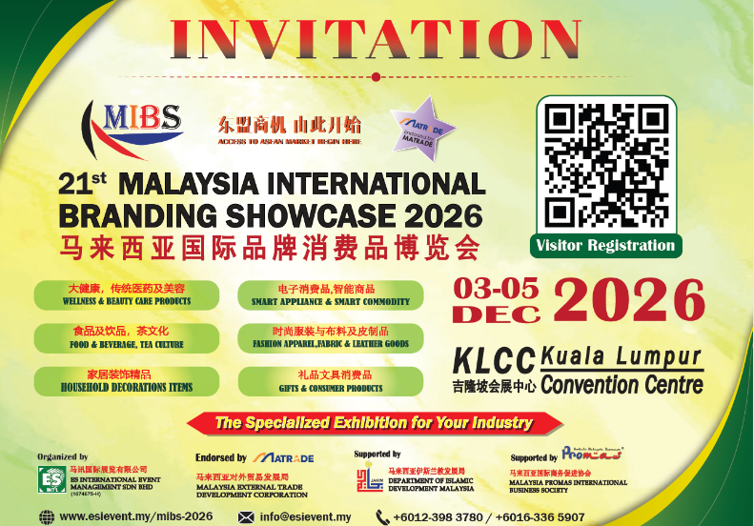
To further strengthen business matching opportunities, MIBS 2026 will organise dedicated Business Matching Sessions, connecting local and international professional buyers directly with exhibitors. These sessions aim to facilitate targeted engagement among manufacturers, brands, importers, exporters, distributors and buyers, encouraging effective sourcing and tangible business cooperation.
MIBS 2026 will also introduce a dedicated Buyer Programme, inviting trade associations and business organisations from across Malaysia to organise buyer delegations to the exhibition. Buyer groups of 25 persons or more will be provided with complimentary round-trip bus transportation, while eligible corporate buyers will be provided with one night's accommodation at a three-star hotel, encouraging greater participation from professional buyers and facilitating meaningful business engagement.
In addition, the Opening Ceremony of MIBS 2026 will be held on the morning of 3 December 2026, with representatives from relevant government agencies, foreign trade and commercial offices in Malaysia, local and international trade associations, industry organisations, supporting partners, exhibitors and members of the business community invited to attend.
Through its exhibitions, business matching activities and industry exchanges, MIBS 2026 aims to strengthen connections between Malaysian and international businesses while helping companies explore opportunities in Malaysia and the wider ASEAN market.
MIBS 2026 warmly invites business leaders, entrepreneurs, buyers and trade professionals from Malaysia and around the world to gather at the Kuala Lumpur Convention Centre (KLCC) from 3–5 December 2026, 10:00 a.m. to 6:00 p.m., to discover new business opportunities, expand their networks and explore the Malaysian and ASEAN markets.
MIBS 2026 — Connecting International Brands with ASEAN Markets.

