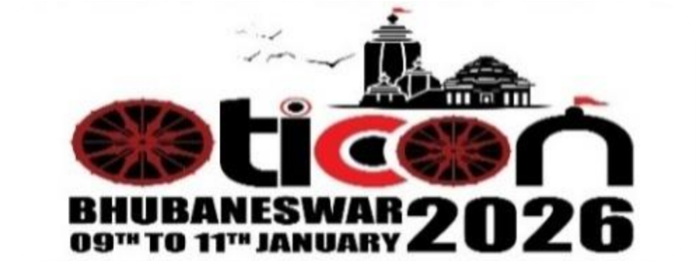
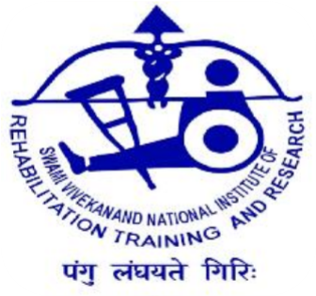
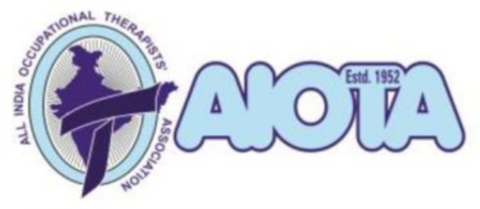

AUTHOR DETAILS

OTICON- 2026

The 63rd Annual National Conference of AIOTA
Theme- "Tradition to Technology: Embracing Cultural Diversity in Occupational Therapy"
9th – 11th January 2026 | S‘O’A Auditorium, Campus II, Bhubaneswar, Odisha
REPLY AND UNDERTAKING FORM
(Submit only via Email in Word File Format)

AIOTA Membership No:
Full Name of Principal Author:
Principal Author’s Affiliation:
Postal Mailing Address (Including Mobile No. & Email):
Co-Author’s Full Name:
Co-Author’s Affiliation:
Title of the Paper/e-Poster/IT/Mini Movie:

PRESENTATION CATEGORY: PLEASE () IN THE APPROPRIATE BOX)

A. Non-Competitive Category ☐ Non-Competitive Oral Paper
☐ Non-Competitive e-Poster
☐ Non-Competitive Mini Movie
B. Competitive Category (Award/Trophy & Theme Selection)
S.NO. | AWARD NAME | THEME/CATEGORY | TICK ()
1. | Kamla V. Nimbkar Award | Best Scientific Paper (Any Topic / OTICON 2026 Theme) | ☐
2. | Vijay Suple Award | Best Scientific Paper in Mental Health | ☐
3. | Ona Desai Award | Best Scientific Paper in Neuroscience | ☐
4. | AIOTA Award | Best Scientific Paper in Pediatrics | ☐
5. | M. M. Sangoi Award | Best Paper on Ergonomics, Environment & Access. | ☐
6. | Bharti Kirti Patel Youth Talent Award | For OTs Graduated After 1st Jan 2021 (Any Topic) | ☐
7. | AIOTA Award | Best e-Poster | ☐
8. | N. Swaroop Award | Best Innovative Technology | ☐
9. | Nirmala Venkateswaran Award | Best Mini Movie | ☐

WRITTEN INFORMED UNDERTAKING – COPYRIGHT DECLARATION
- I/We hereby declare that the submitted work is original. I/We have read and agree to the rules and regulations for submission, and:
  - Wish to compete ☐ Do not wish to compete

For the following award(s) (Mention Sl. No 1-9):

- I/We affirm that:

- The same paper/e-Poster/Innovative Technology/Mini Movie has not been presented at any other conference.

- If accepted, AIOTA reserves the right to publish the work in the Indian Journal of Occupational Therapy (IJOT).

- I/We will comply with all publication guidelines before submission to IJOT.

- The decision of the Scientific Program Committee and Jury in respect to all issues related to scientific
submission and presentations shall be final and binding.

- The information about acceptance and/or rejection of the paper in the Conference/IJOT will be conveyed to
the principal author.

Signature of Principal Author: ____________ Place & Date: _________________________
Signature(s) of Co-Author(s):

ENCLOSURES (ATTACH AS WORD FILE):

- Official Abstract Form in word files (.doc or .docx format only)
- Research Abstract in word files (.doc or .docx format only)
- Scanned certified copy of the Degree Certificate in Occupational Therapy (for Youth Talent Award applicants only)

FOR OFFICE USE ONLY:

Scientific Presentation: ☐ ACCEPTED ☐ NOT ACCEPTED
Remarks (if any): ________________________________________________________________
Chairperson, Scientific Program Committee

SUBMISSION DETAILS:
Email this form to:

Dr. Pragyan Singh, OT, Ph.D.
Chairperson, Scientific Program Committee – OTICON 2026
Mobile: +91-9861039434

Email: scientificchairperson.oticon26@gmail.com
Dept. of Occupational Therapy, SVNIRTAR, Olatpur, Bairoi, Cuttack – 754010

Form available for download at: www.oticon2026.com

