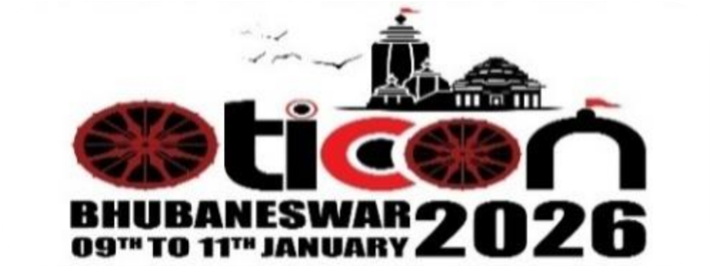



OTICON-2026

The 63rd Annual National Conference of AIOTA
Theme-"Tradition to Technology: Embracing Cultural Diversity in Occupational Therapy"
9th – 11th January 2026 | S‘O’A Auditorium, Campus II, Bhubaneswar, Odisha
COMMON ABSTRACT FORM FOR ALL SCIENTIFIC PRESENTATIONS

(Please use block letters only)

AIOTA Membership Number:
Title of Paper/e-Poster/IT/ Mini-Movie:
Author (s) | Corresponding Author:
Author (s) | Co-Author:
Competitive/ Non- Competitive:
Award Category:
Institution with Address, Contact Number & E-mail ID:
Registration Number- OTICON-2026:
Date:

ABSTRACT (Within 350 Words Only):

BACKGROUND & RATIONALE:
OBJECTIVES:
METHODOLOGY:
RESULTS:
CONCLUSION:
KEYWORDS:
REFERENCES:

Signature of the Corresponding Author
Signature of the Co- Author

Note: This form should reach to Chairperson Scientific Committee, E- Mail- scientificchairperson.oticon26@gmail.com,
on or before 15.09.2025 for both Competitive and Non-Competitive category along with duly filled reply form in word file (.doc or .docx) format only.
OVERVIEW OF ABSTRACT FORMAT CRITERIA CATEGORY OTICON-2026

CRITERIA | SCIENTIFIC PAPER | e-POSTER | INNOVATIVE TECHNOLOGY | MINI MOVIE
Word Limit | Up to 350 words | Up to 350 words | 250–300 words | Up to 250 words
Title | Up to 150 characters | Up to 150 characters | Up to 150 characters | Up to 150 characters
Authors | Required | Required | Required | Optional
Background | Define gap, justify study | Relevance to Occupational Therapy | Clinical rationale | Theme relevance
Objectives | Research aim | Poster aim | Innovation goal | Message/goal
Methodology | Design, tools, sample | Brief overview | Development & testing | Narrative/script
Results | Key findings | Key insights | Features & response | Impact & takeaway
Conclusion | Clinical relevance | Topic value | Utility & scope | Intended impact
Trial Registration | Optional | No | No | No
Funding | Optional | Optional | Optional | Optional
References | Max 2 | Max 2 | Max 2 | Optional
Keywords | Required | Required | Required | Optional
Format Note | IJOT +  plagiarism check | - | - | MP4, 4 mins,  no copyright

