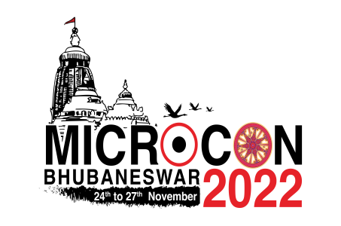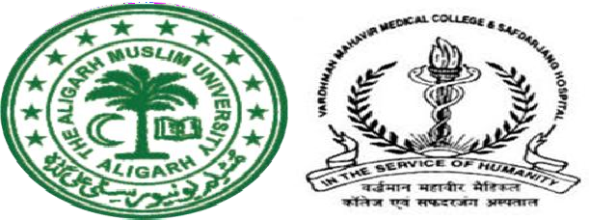
Scientific Workshop: Biomedical Waste Management, 23.11.2022, AMRI, Bhubneshwar
Resource Person: Dr Malini R Capoor, VMMC & SJH, Chairperson: CPCB/VMMC & SJH
Time (Hrs) | Topic | Speaker
0930 - 1000 | Inaugural Address & Importance of BMWM in Healthcare & role of administrative. Dr B.L.Sherwal,MS VMMC & SJH,
1000 - 1030 | Introduction of the Delegates to the Workshop & Pretest | Dr. Malini R Capoor, VMMC & SJH
1030 - 1100 | Policy and Guidelines for biomedical waste management | Dr. Malini R Capoor, VMMC & SJH
1100 - 11:30 | BMWM rules 2016,2018 & 2019 and CPCB guidelines 2022: Legal Aspects, Authorization,  Annual Report | VMMC & SJH
1130 - 1200 | Role & function of Regulators: Central Pollution Control Board & SPCB | Dr Youthika Puri, CPCB
1200 - 1230 | Kayakalp, NQUAS, Parameters, Thematic Areas Related  to BMWM | Dr. J N Srivastava, NHSRC
1230 - 1300 | BMWM in COVID 19 Context and Monkeypox context vaccination waste, Home Care waste | Dr. Malini R Capoor, VMMC & SJH
1300 - 1330 | LUNCH
1330 - 1400 | Lab Waste & Liquid Waste Management | Dr. Annapurna Parida  EX,VMMC & SJH
1400 - 1430 | Management of Biomedical waste in Orissa: An overview | Dr Youthika Puri, CPCB  Orrissa pollution control board
1430 - 1500 | Health care Waste Management in Captive Facility: RIMS Imphal Experience | Dr. Sanjib Singh, MS, RIMS Imphal
1500 - 1530 | Solid waste management in Health Care facilities | Chintan, Solid waste expert
1530 - 1600 | Demonstration of BMWM AUDIT APP, Immunization Waste Needle cutter video | VMMC & SJH
1600-1630 | Treatment technologies for BMWM | Dr. Varsha Gupta, GMC Chandigarh
1630 - 1645 | Demonstration of Barcoding | Mr Sarabjeet Singh
1645-1705 | NABH/NABL parameters for BMWM | Dr. Sunita Sahu, Apollo Bhubneshwar
1705-1730 | Panel on BMWM | OPEN HOUSE
1730 - 1800 | Post test & Discussion | Dr. Annapurna Parida,  EX VMMC & SJH

