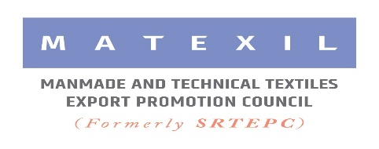

**Vietnam International Textile & Apparel Accessories in Vietnam from 25 to 28 September, 2024**

**Participation Fees/Support under MAI Scheme**

**Please note that Participation Fees of Rs.2.40 Lakhs for a booth of 9 sqm is the Commercial Rate (without any financial support under MAI Scheme). The Council has submitted the MAI proposal for participation in the above event under the MAI Scheme. However, approval is still awaited. We have charged participation fees at Commercial Rate pending approval under MAI Scheme. If the Council gets approval under the MAI Scheme, a suitable amount will be refunded to the participants.**

**Criteria for availing reimbursement of air-fare, subject to the approval of MAI grant :**

* Reimbursement of airfare is eligible to the exporting company having the export turnover **below Rs.50 crores** (FOB value) in the preceding financial year. Please note the export turnover of the participating company should be between Rs.50 Lakhs to Rs.50 crores of previous year (2023-24)
* Members to have completed 12 months of Membership and are regularly filing Export returns with the Council.
* Permissible only to the regular Director / Partner/ Proprietor or a regular officer of the company on Senior Managerial Position (not admissible to a foreign national)
* Claim forms duly filled in and complete in all respects must be submitted to the Council within 30 days of completion of the event. Need to submit all travel documents like tickets copies with cost, boarding passes etc.
* Initial Application form for claiming re-imbursement of airfare should reach the Council 16 days prior to your departure date.

**Conditions for availing MAI subsidy:**

* An exporter can avail MAI benefit for participation in 3 approved events in a financial year. 4th time participation in the Fair will be allowed without MAI subsidy.
* An exporter can claim MAI benefit for participation in one booth only. Additional booths can be booked by the participant without MAI benefit (One booth will be allotted for one company under MAI Scheme)
* A maximum of three participations in a particular trade fair/exhibition would only be eligible for MAI assistance, i.e., members who have availed assistance three times (including past cases) for a particular fair/exhibition, thereafter, must participate in that fair on their own.

*****************