User Manual (For Exporters)–e-Wallet System
Point to Note-
- The e-Wallet system allows for bulk payments to save the payment gateway interaction time in each submission.
- The e-Wallet balance shall be specific to the payments credited to any specific issuing agency. The credit against one agency cannot be re-used for any other issuing agency.
- Only those issuing agencies which have chosen to opt for e-Wallet shall be shown as options for the exporter.
- Exporters can credit against multiple agencies.
- Maximum amount that may be credited to the e-Wallet shall also be as per administrative concurrence of the issuing agency.
Steps for Use-

- The “My e-Wallet” menu is provided on the Exporter’s dashboard. On clicking the panel below details shall be shown which shall show the total balance of E-Wallet to the exporter. Below is a sample screen where Name, Total Funds added, Total Amount utilized, Total balance available with the agency(s) shall be shown.
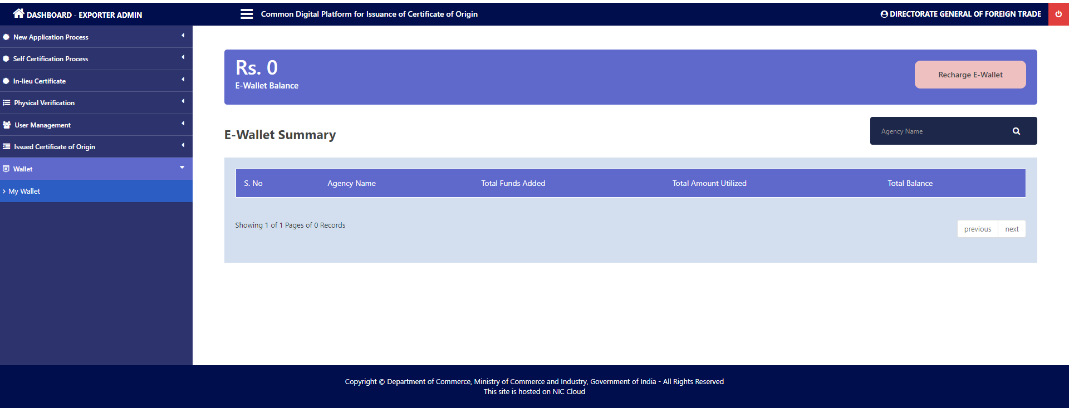

- On clicking “Recharge E-Wallet” button a panel show as follows -
The fields given in the panel are below:
- Select Agency: The name of Agency(s) will be shown in this drop down. Only the Global Admin can activate agency for e-Wallet.
- Please enter the Amount
- I Agree: By clicking this shows that you agree the conditions given.
- Add Money To E-Wallet: After clicking this it will go to payment gateway for further payment process.

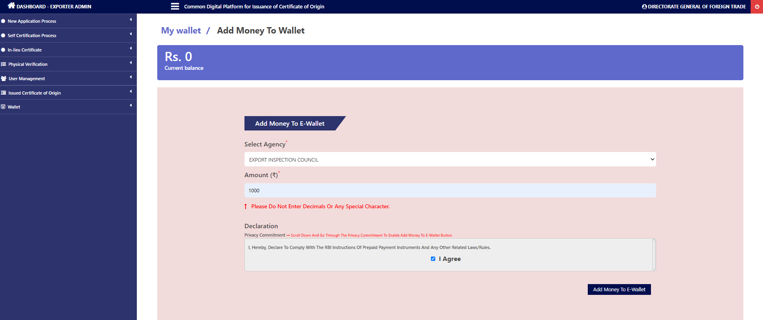

- After successfully adding the money to Agency. It will show a message and details of the payment will be shown. In this case below we are adding Rs. 1000 to the wallet for Agency concerned. On the money shown in Total Funds added there is a link given to show all such transaction details.
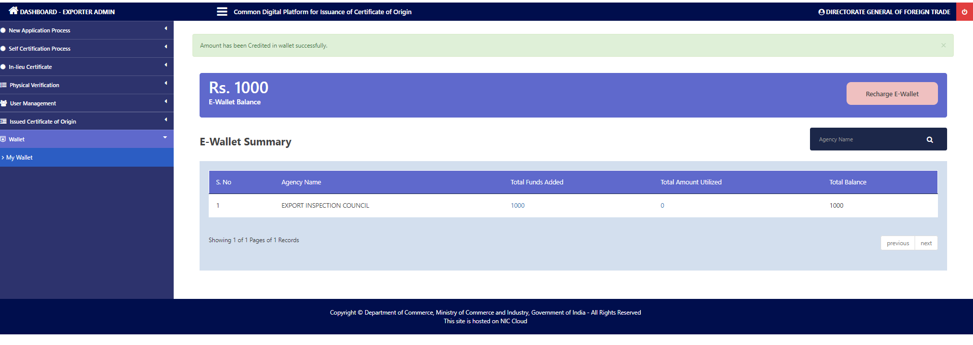
- Clicking on money will land us to new page having details regarding all the money added to the wallet.
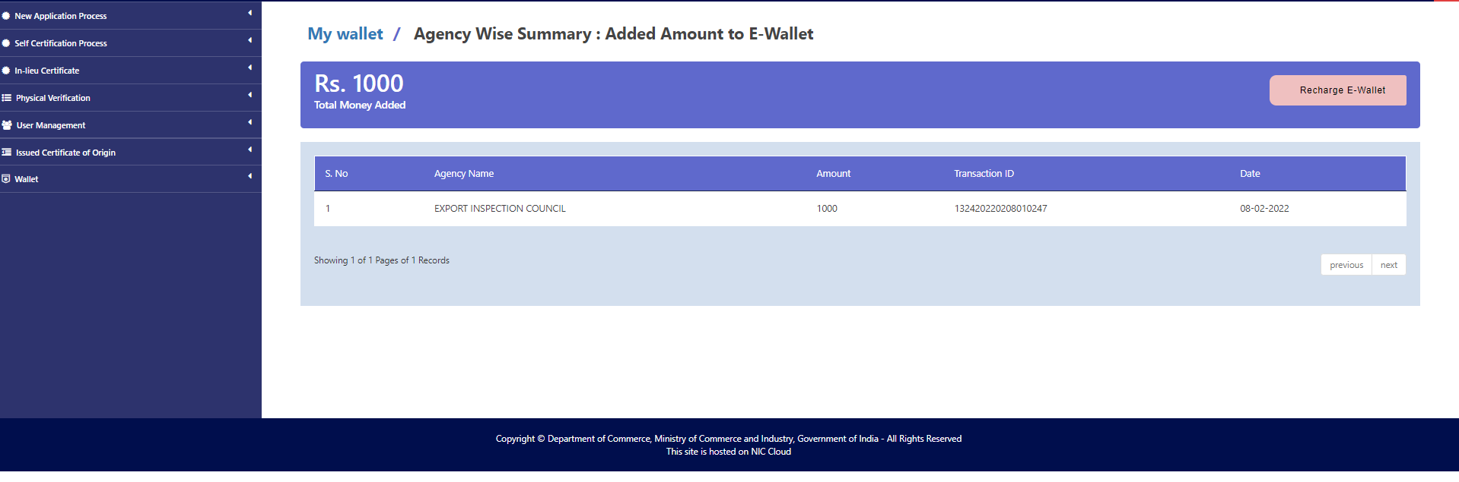

- For using this e-Wallet for submission of CoO applications, please go to menu “New application process -> Application Pending Payment” -->“Make Payment”. Clicking this will take you to the next page.
- 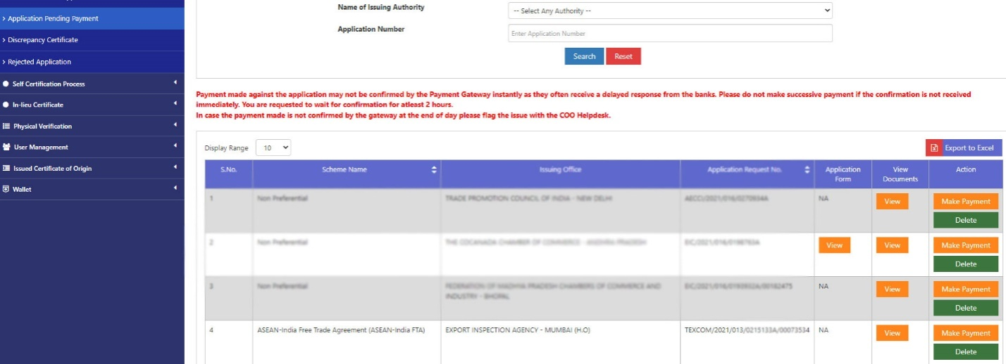

- On this page we have a new button “Payment by e-Wallet”. For payment from e-Wallet, please click on the same.
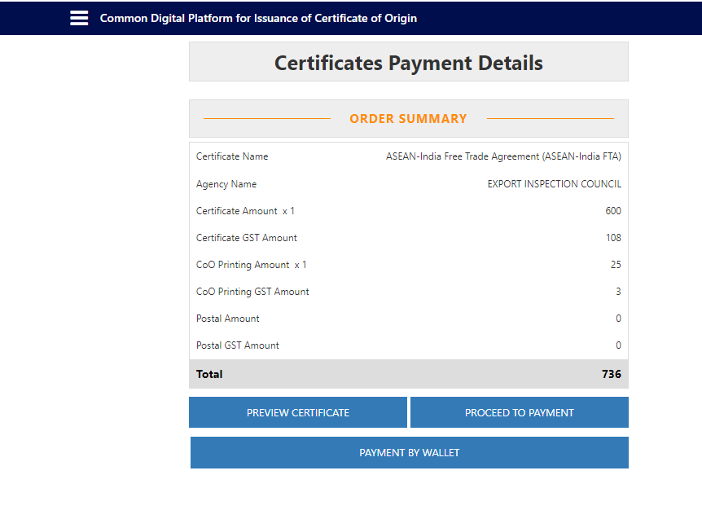
- In the next screen the password of the Exporter applicant shall be requested for a second level confirmation.
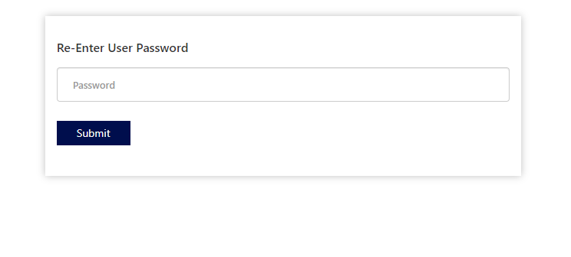
- The next screen shows detail of payment and wallet balance. After clicking “PAY” the amount will be deducted from Wallet account of the exporter.

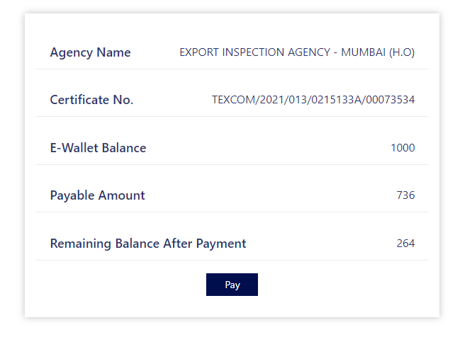
- Screen as below shall be shown if the Payment is successful.
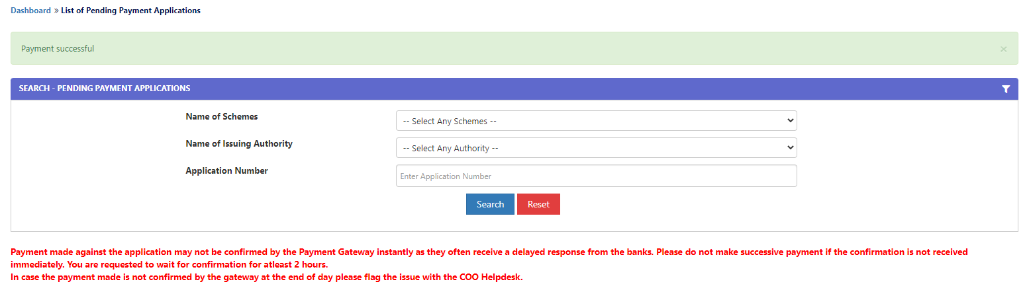
- At My Wallet Summary page, the entry for Amount Utilized is shown. Clicking on this will lead to next screen.
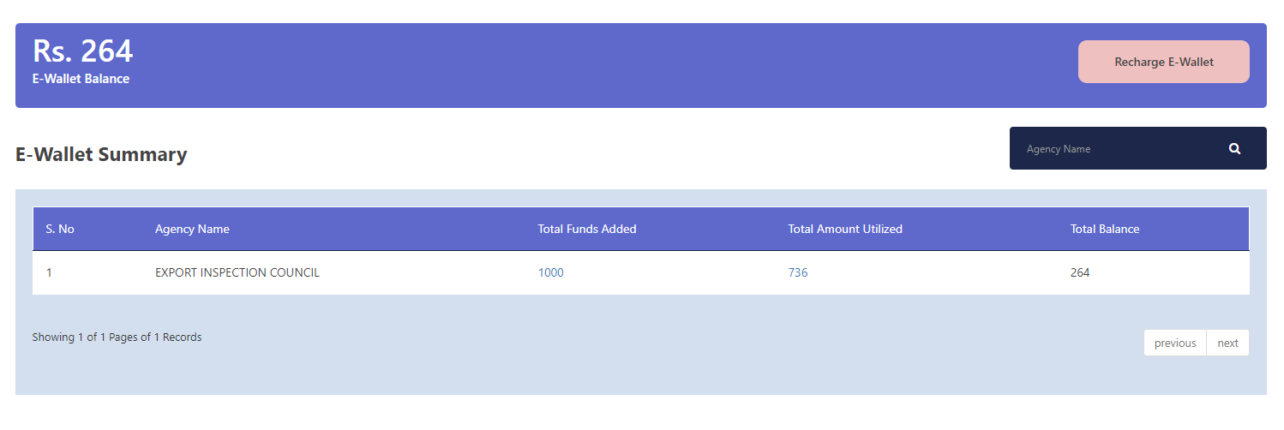
- Following details of the payment done by Exporter may be seen here-
