FICCI Industry 4.0 Awards for Manufacturing

Introduction
FICCI Industry 4.0 committee is shaping the Indian industry 4.0 scenario through its work on policy advocacy, industry awareness on various topics related to the same. As a next step, the Committee would like to provide platform to the showcase the successful digital transformation use cases in India in various areas. To do so, the Committee is instituting country’s first of its kind FICCI Industry 4.0 Awards.
FICCI would like to invite applications from the manufacturing organizations (including oil & gas sector) which are ahead on the path of digital transformation and would like to show case their achievements as a case for others to follow. Multiple units of same organization can apply for these awards. FICCI is happy to announce 2 broad categories for these awards:
- Focused project category is for those units which have undertaken pilots in a specific area of operations in their unit and have achieved early successes
- Overall digital transformation program category is for those organizations which have undertaken massive efforts to integrate digital business successfully in their existing business models and digital transformation program is shaping their journey.

Firms/Units in manufacturing (including oil & gas) are requested to classify themselves in the following categories first and then apply in above mentioned broad categories:
- Large sized organization (Organization having either turnover or investment excluding working capital more than Rs 500 crore)
- Medium sized organization (Organization having either turnover or investment excluding working capital between Rs 100 crore to Rs 500 crore. If any one of the parameters crosses the higher limit of Rs 500 crore then the organization is categorized as large sized organization)
- Small sized organization (Organization having turnover & investment excluding working capital both less than Rs 100 crore)

Application Process:
- Preliminary Application Round:
- Completion of the application form (Some of the questions are marked as optional with *. Estimated efforts ~ 3-4 hours without optional questions)
- PowerPoint presentation of not more than 20 slides
- Video presentation of 5 minutes

- Mentoring / Alignment session:
- How the focused project is aligning with the focused project category of FICCI Industry 4.0 framework
- Understand how the future state was envisioned and indicate set of appropriate KPI which will better reflect the impacts achieved by the project execution.
- Depending upon the current milestone realized, select the granularity of the data available (Annual / Quarterly)
- Submit revised application with additional information as agreed

- Site visit Round (if shortlisted)
- Visit by Team of experts will be undertaken for a detailed interaction with various stakeholders firsthand. Applicant unit will get chance to interact with these experts to shape their next steps.
- Assessment process will be led by a team of domain experts.
- This can be in person or virtual visit.

- Evaluation by team of eminent expert juries
  - Finalist applicants will be invited to make presentation to team of juries
  - Jury will select the winners based on assessment, presentation, and results achieved

- Grand award ceremony in the presence of eminent personalities to recognize the achievements of finalist applicants

Charges (INR) | Large industry | Medium Scale | Small scale, Startups
Application fees | 40,000 plus GST | 25,000 plus GST | 15,000 plus GST
Site visit (if short listed) | 10,000 (per man day, up to 2 man-days) plus GST | 10,000 (fixed charges)  plus GST | 10,000 (fixed charges)  plus GST

FICCI Industry 4.0 Award Categories

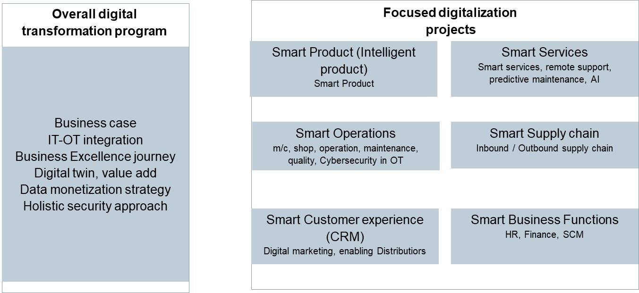

FICCI Industry 4.0 Framework

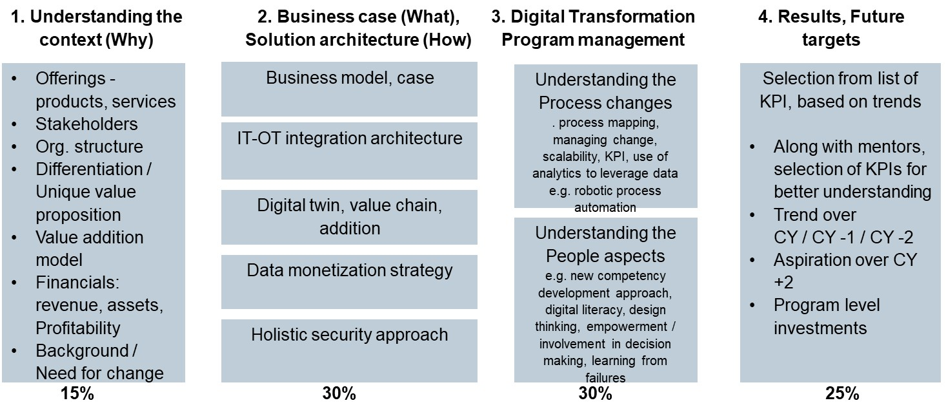

 | Award Categories select the application category
A | Focused project category  (Please refer to Annex 2 to know more details about the categories)
1 | Smart Product | 4 | Smart Supply chain
2 | Smart Customer experience | 5 | Smart Services
3 | Smart Operations | 6 | Smart Business Functions
B | Overall digital transformation program

0 | General information
0.1 | Name of the organization
0.2 | Address
0.3 | Financials  (Please mention for the highest legal unit relevant for the application.  Please provide for current year and past 2 years)
 |  | CY - 2 | CY - 1 | Current Year (CY)
 | Parameters | 2018 | 2019 | 2020
A | Sales (INR mio.)
B | PBT (INR mio.)
C | Fixed Assets (INR mio.)
D | Working capital (INR mio.)
E | Employees (nos.)
0.4 | Business Unit applying for the award
 | Address
 | Contact details

1 | Understanding the context (why)  Please help us to understand why this project was necessary. |  |  |  | Marks 150
1.1 | Product / Offerings
1.2 | Financials  (Please mention for the business unit relevant for the application.  Please provide for current year and past 2 years)
 |  | CY - 2 | CY - 1 | Current Year (CY)
 | Parameters | 2018 | 2019 | 2020
A | Sales (INR mio.)
B | PBT (INR mio.)
C | Fixed Assets (INR mio.)
D | Working capital (INR mio.)
E | Employees (nos.)
1.3 | Stakeholders  - External stakeholders –  - Internal stakeholders – like employees, suppliers etc
1.4 | Leadership vision |  |  |  |  | Marks  50
1.5 | Background, need for change |  |  |  |  | Marks  50
1.6 | Please describe leadership involvement, communication, monitoring, etc. |  |  |  |  | Marks  50

2 | Business / Use case (What), Solution architecture (How)  Please describe your technical approach followed in implementation of your business case. For more info. On Use case methodology, please refer to Annex 1 (Questions marked with * are optional, attempts to answer these will provide additional marks.) | Marks 300
2.1 | Business model, use case  - You may describe as write-up, block diagram  - Please What were primary objectives, pre-conditions, assumptions, interfacing with other systems  - Did you use any templates as mentioned in IEC 62559 – 2. | 60
2.2 | Solution architecture for IT-OT integration  - Please describe key components, hierarchy of your solution.  - Which standards, protocols you have chosen and what benefits were relevant in their choice e.g. open protocols, wider acceptability within eco system, in-house ability to maintain.  - Did you hire any external support during selection, implementation, and system integration phase?  - Describe your approach to move beyond pilot phase and scale up across organization. | 60
2.3 * | Use of digital tools for planning, simulation  - To mitigate the risks during implementation / operations phase, what kind of digital tools (e.g. digital twin, simulation) were used to check feasibility of the project?  - Please comment on fulfillment of primary objective, to scale the project further, to interface the results with other systems. | 60
2.4 * | Data strategy, monetization approach  - Please describe your approach towards data collection, data storage, data management.  - Which aspects of data such as trust, protection, privacy, proprietary, integrity, accessibility, integration with cloud infrastructure are critical to your project.  - How do you plan to fully leverage the data collected? | 60
2.5 * | Holistic approach to Cybersecurity in OT environment  - How did you identify possible security threats in your operations? Describe functional requirements (covered in IEC 62443 series) that were targeted to secure your operations e.g. zoning, DMZ, deployment of secure hardware.  - How did you integrate information security related aspects in overall design? | 60

3. | Digital Transformation program / project management
3.1 | Understanding the process transformation drive  (Use the questions below to describe your program / project. Questions marked with * are optional, attempts to answer these will provide additional marks.) | Marks 150
a. | How did you derive necessary changes required in processes related to your program / focused project? e.g. process mapping to eliminate nonvalue additions, simplification, automation, digitization, etc. | 25
b. * | Which approach was followed for your program / focused project to derive necessary changes for digital transformation? e.g. understand data required, its integration in decision making for your organization. Are there any Robotic process automation, AI based approach considered, deployed? | 25
c. | Which specific KPIs were chosen to quantify benefits realized directly from your program / focused project? How did you quantify the process improvement targets? Did you monitor realization of progress in real time? | 25
d. | Please describe approach followed to drive the identified focus interventions. E.g. Pilot project, dedicated team, cross functional approach, etc. How did you review the progress and at what frequency? | 25
e. * | How did you integrate the results of your project with overall business processes? How do you plan to scale up the results achieved? | 25
f. | Whether the team encountered any failures during implementation. Please describe how the overall lessons learnt were shared within the organization. | 25

3.2 Understanding people aspects during transformation  (Use the questions below to describe your program / project. Questions marked with * are optional, attempts to answer these will provide additional marks.) |  | Marks 150
a. | Please enumerate how your Industry 4.0 strategy focused on harnessing people skills, competencies beyond mere deployment of production technology | 25
b. | To leverage achievements of your project, which new skills identified. Please describe how your team went about identification of these new skills | 25
c. * | What changes were made to exploit the insights gained from the data being collected e.g. more empowerment to operational teams? What people specific aspects were relevant to overcome challenges faced due to access to more granular and real time data e.g. more frequent decision making hence decentralization was pursued | 25
d. | How team is encouraged to share lessons learnt from failures? How people are able to apply insights gained from the data analysis? | 25
e. | How are you adopting your culture, values to new way of working especially with new digital skills? How the management at various levels communicated the need for competency development within internally – externally e.g. with suppliers, distributors? | 25
f. * | How the employees were trained for the new edge skills? Any new pedagogies deployed to impart training using new methods e.g. virtual training, augmented reality, virtual reality? | 25

4 | Results Please refer to Annex 2 for relevant KPIs |  |  |  |  | Marks 250
 | - How did you quantify objectives / results needs?  - Please mention below at least 5 KPIs which were chosen to attribute the benefits realized out of this project specifically.  - Current year is your Financial Year in which this application is being made.  - To understand the trend of the results -  - Please provide data over past 2 years  - If results available are for less than 1 year, then please provide data over last 3 quarters  - Results need to be confirmed by company CFO that they are true and were accounted in the official MIS / Results in the respective FY  - If it is not possible to provide year wise targets for next 2 years, then at least aspirational target to be mentioned.  - If additional KPIs can help to better quantify the results achieved, please provide the same. |  |  |  |  | 50 marks per KPI
1 | KPI
Definition:
FPY = First Pass Yield measured at the end of line
Formula: Specify the variables, units of the same as well

FPY in % = Output quantity accepted / Batch quantity produced

Output quantity accepted = Output accepted as per the requirements specified in numbers
Batch quantity produced = Batch quantity produced in numbers
Target: How did you quantify objectives / results needs
Improve FPY from 78% to 95% in next 2 years
 | CY – 2 | CY - 1 | Current Year (CY) | CY + 1 | CY + 2
Plan
Actual
 | Comments: Please add comments to understand the results of necessary
Note-
- Add above template to for next set of KPIs.
- During mentoring session, applicants will be guided to select appropriate KPIs

Annex 1
Understanding of the Use case methodology
(based on IEC 62559 series)

The concept of use cases originates from software engineering where it is used to identify functional requirements. A use case is simply a “story” about how a system will be used, ideally developed by the people who will be using it. Use cases permit “users” to express their information needs clearly and comprehensively in a manner that can be used by information specialists and design engineers to develop the ICT/automation systems that will exactly meet their requirements.

Thus, its focus is on the description of general functionalities of systems under design and their environment. In general, the description of use cases is independent of design specifics and allows the identification of requirements. They provide links to artefacts from different development viewpoints and due to that, they support a common understanding between experts from different domains and technical/IT experts who must implement these functions.
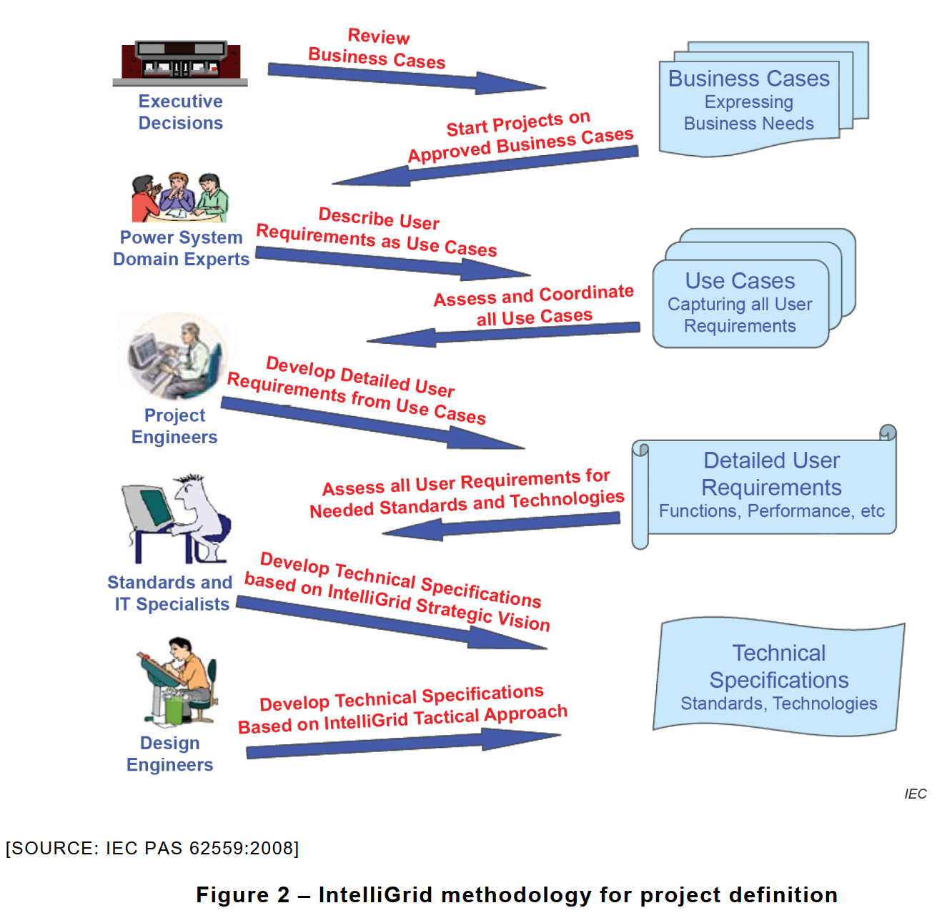

Annex 2

Award categories

Focused digitalization projects are for those units which have undertaken pilots in a specific area of operations in their unit and have achieved early successes.
Description below is provided for broad understanding of the categories. Category description is based on related use cases, typical approaches.
Selection of appropriate key performance indicators help in understanding the impact of the results achieved. Please provide mix of “Lead” and “Lag” indicators appropriate for the context of the use case. For better understanding, refer to following scenarios.
- Scenario 1 - execution completed and the targeted results are yet to be realized, then choice of “Lead” indicators help to understand how future coarse corrections will be managed
- Scenario 2 - execution completed and targeted results realized, then “Lag” indicators will help to understand how the project steering was done

KPIs described below indicative. To understand the trend of the results -
- Please provide data over past 2 years
- If results available are for less than 1 year, then please provide data over last 3 quarters
- If it is not possible to provide year wise targets for next 2 years, then at least aspirational target to be mentioned.

One might have undertaken digital transformation over multiple areas, in that case choose the area where KPIs have shown significant improvement. Also, one may consider applying in multiple categories based on stronger results.
For unit wide digital transformation, it is highly recommended to apply in “Overall digital transformation category” of the award

- Focused project categories
- Smart Product (intelligent products) –
  - Related use case – Limited customization possibilities, longer product introduction cycles, complex product varieties leading to higher set up times
  - Approach – Innovations based on Smart product life cycle management, use of digital twin, virtual simulations, design to cost, design to manufacturability, integration of sensors, product platform strategy, standardization of hardware platform and differentiation thru apps, extension of useful life
  - Key performance indicators – Product innovativeness, unique product platforms, product modularity, reduced variety, Faster response to customer requests, quicker engineering changes, increase in premium, reduced time to market, increase in market size based on innovativeness, integration to other apps providers, % digital value add
  - Scope – Smart products, digital twins, digital products

- Smart Customer experience (CRM)
  - Industry 4.0 is about delivering personalized products at mass production costs. This needs organizations to shift their focus from merely satisfying customers to enhance customer experience – from presales, during execution and after sales as well.
  - Related use cases – Information silos across departments such as sales, operations, service, no complete overview of the customer relationship especially at prospect stage, thereby limited share of wallet, typically data is gathered only at transaction points, does not contain behavior aspects
  - Approach - Successful units use digital mediums to not only reach out to customers but also to engage with them. They analyze their behaviors, motivations to design digital touch points e.g. newsletters, white papers. /they use online channels such as pod casts, webinars, master classes by thought leaders to shape their behaviors
  - Key performance indicators - product configurators to offer personalization, % sales thru product configurators, % engagement across different channels, % share of wallet, % sales: repeat purchase, referrals, upsell, cross sell, % sales based on digital offerings, Net promoter Score (NPS), customer testimonials, no. of customers signed up in loyalty program, online purchase mall,
  - Scope – Units can consider innovations in the areas of marketing, product management, business development, frontline sales functions, enabling distributors, etc.

- Smart Operations (machine, shop, operations, maintenance, quality, Cybersecurity in OT)
  - Related use cases – quality issues, uneven material flow, capacity constraints, variations in processes, nonconformances. Cybersecurity vulnerabilities, Additionally, stakeholders are demanding focus on reducing energy used during process of value addition, sustainability aspects while sourcing, recycling end of life products.
  - Approach - These challenges can be dealt thru using process modularization, one piece flow, traceability of data for real time quality, use of RFID for data processing, mobile user interfaces for M2M communications, digital lean, agile processes, sensors to gain much granular process data, analyzing data in real time to support production decisions. Holistic security concept deployment
  - Key performance Indicators - Throughput, OEE, material / energy efficiency, labor productivity, response to changes, both delivery issues: reliability capability, pr
  - Scope - Units can consider operations related to a single machine, production cell or complete manufacturing itself

- Smart Supply chain
  - Related use cases – No regular feedback about status of completion, no access to in process quality records, Inability to trace back to supplier records in case of problems in fields, delayed resolution to queries, Buffer stocks at multiple stages
  - Approach - Optimized supply chains with complete traceability, transparency of the quality, and have simple but effective interfaces to smoother information / data flows across the supply chain, push – pull methods for managing supply process, Just-in-Time, Collaborative robots in inventory management
  - Key performance indicators – optimization of warehouse space, overall reduction in inventories across the supply chain, real time transparency / access to data. Faster response based on agreed service levels / conditions / events / escalations; preventive approach due to better traceability, reduction in manual touch points e.g. ordering, GRN, etc.
  - Scope – in bound supply chain up to tier 2 suppliers, outbound logistics up to retailers, warehouse management, transport logistics, return logistics, etc.

- Smart Services
  - Related use cases - focus on reactive services such as breakdown maintenance, on site services, repairs, etc.
  - Approach – Smart services, remote support, predictive maintenance, AI
  - Key performance indicators - % sales from smart / digital services, quick in response, overall reduction in resolution time, increase in uptime for customers, reduced down time during planned maintenance, increased transparency in energy usage during operations, customer testimonials
  - Scope - Innovations deployed during operations or after sales phase of the lifecycle.

- Smart Business Functions
  - Related use cases -
  - Approach - Digitalization in support functions to take care of routine issues, tasks, queries
  - Key performance indicators – higher labor productivity, reduced per transaction costs, reduction in office space, conversion of fixed costs in operating costs, higher employee satisfaction, higher touch time of frontline employees from sales, service, order processing, etc.
  - Scope – HR, Finance, SCM, Back office functions such as sales order processing, purchase order processing, invoicing, expediting, call center

- Overall digital transformation program category
  - Approach – organization wide massive efforts to integrate digital business successfully in their existing business models, and digital transformation program is shaping their journey. New business models based significant digital value addition
  - Key performance indicators – choose from above

