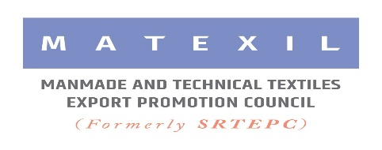

**Financial Grant for member-exporters for participating at IRANTEX in Iran from 19 to 22 August, 2024**

* As MATEXIL (FORMERLY SRTEPC) is organizing participation of its member-companies in Irantex in Iran from 19 to 22 August 2024 under the MAI Scheme of Govt, all eligible participating companies will be offered MAI subsidy for reduced amount of participation charge mentioned in the circular, subject to the fulfillment of certain conditions.
* MATEXIL (FORMERLY SRTEPC) will provide all eligible participants re-imbursement of costs of airfares, subject to the fulfillment of certain conditions.  The reimbursement of cost of economy class airfare to eligible participants will be limited with a maximum ceiling of Rs.90,000/- or the actual ticket cost (whichever is less) subject to approval of MOC under MAI Scheme**.**

**Criteria for availing reimbursement of air-fare :**

* Reimbursement of air-fare is eligible for the exporting company having an export turnover **below Rs.50 crores** (FOB value) in the preceding financial year.  However, member-exporters with zero exports in the last financial year (2023-24) will not be eligible.
* Members to have completed 12 months of Membership and are regularly filing Export returns with the Council.
* Permissible only to the regular Director / Partner/ Proprietor or a regular officer of the company in a Senior Managerial Position (not admissible to a foreign national)
* Claim forms duly filled in and complete in all respects must be submitted to the Council within 30 days of completion of the event.  Please Keep all boarding pass, hotel confirmation copies in Iran, ticket copy with Agent’s bill etc.
* Initial Application form for claiming re-imbursement of airfare should reach the Council 16 days prior to your departure date.

**Conditions for availing MAI subsidy:**

* An exporter can avail MAI benefit for participation in 3 approved events in a financial year. 4th time participation in the Fair will be allowed without MAI subsidy.
* An exporter can claim MAI benefit for participation in one booth only. Additional booths can be booked by the participant without MAI benefit (One booth per company only for MAI eligibility)
* A maximum of three participations in a particular trade fair/exhibition would only be eligible for MAI assistance, i.e., members who have availed assistance three times (including past cases) for a particular fair/exhibition, thereafter, must participate in that fair on their own.

****************